Week 6 Autoencoder

Image segmentation:
2 types of image segmentation:
Similarity: both in pixel-wise
Difference:
- Semantic segmentation – in pixel-wise, classify each pixel into a class. Pixels in the same class can’t be distinguished.
- Instance segmentation – in pixel-wise, classify each pixel into a class, and distinguish each instance in the same class.
Example to show differences: the image includes 2 persons in the grass under the sky
Semantic model will classify pixels of grass and pixels of people, but can’t distinguish 2 persons; while instance segmentation not only classify pixels for grass and people, but also separate 2 persons
Purpose and Downstream tasks
- Purpose: Learn image features
- Downstream tasks: autonomous driving, medical diagnose, image editing, quality inspection
Naïve Architecture – baseline model for semantic segmentation
What: simple a bunch of CNN, each CNN only learns regional image, then concatenate the features as the final output. The final output remains the original image dimensions
Disadvantage: costly – as always keep the original image H and W throughout the net 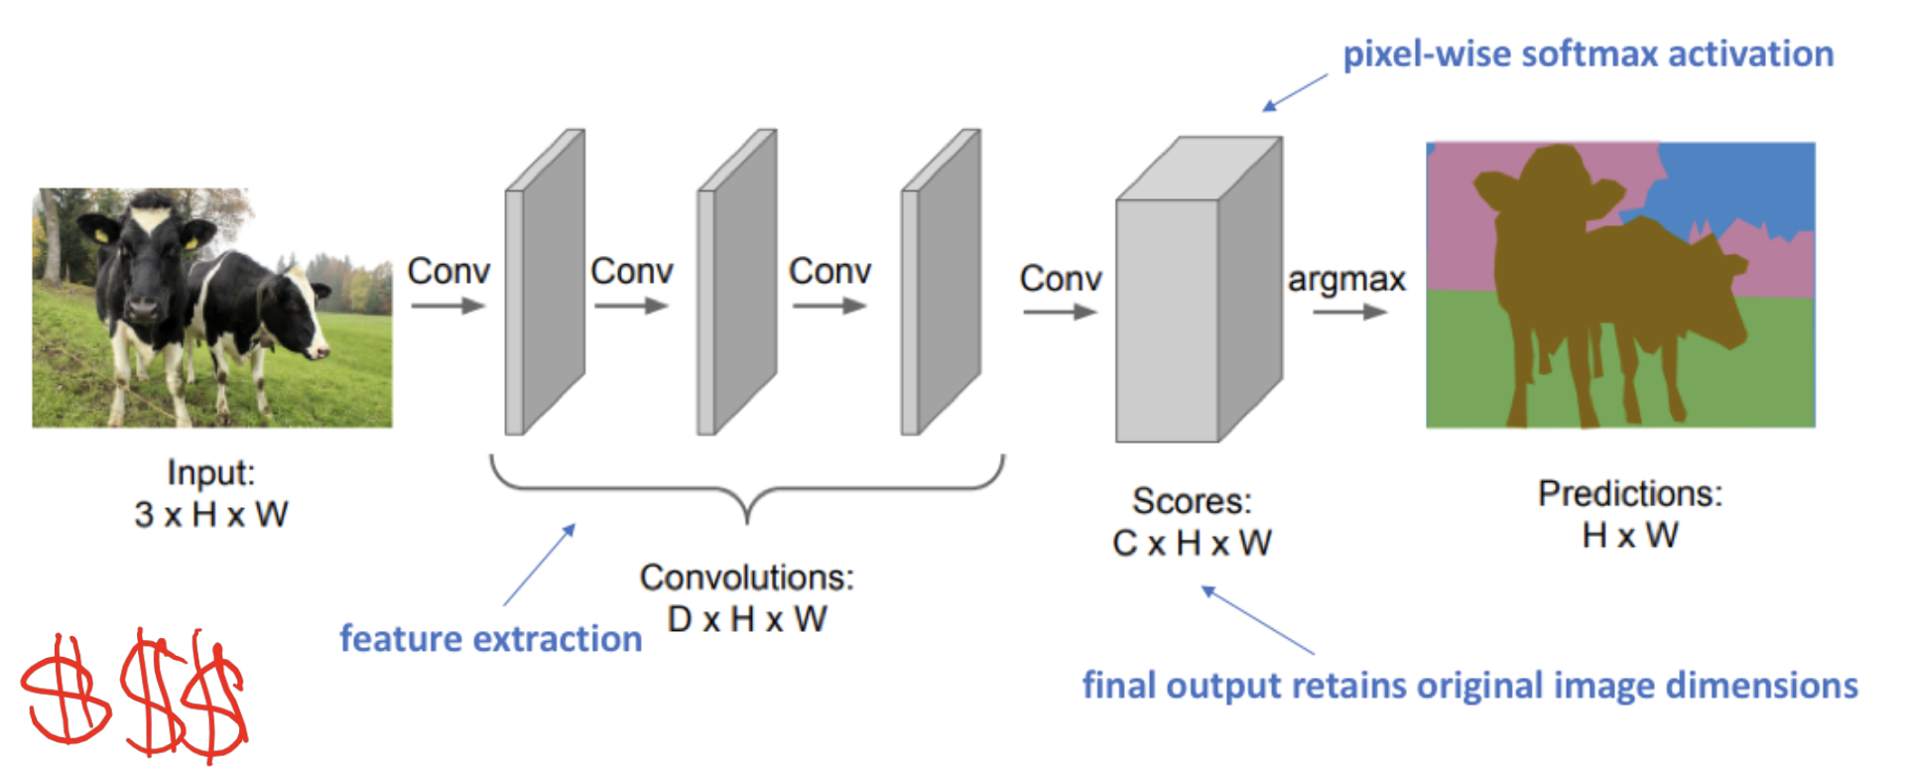

A better approach
Encoder-Decoder approach: Apply downsampling first to increase the receptove field, until compress the image semantic meaning into a latent space, then upsampling to classify pixel
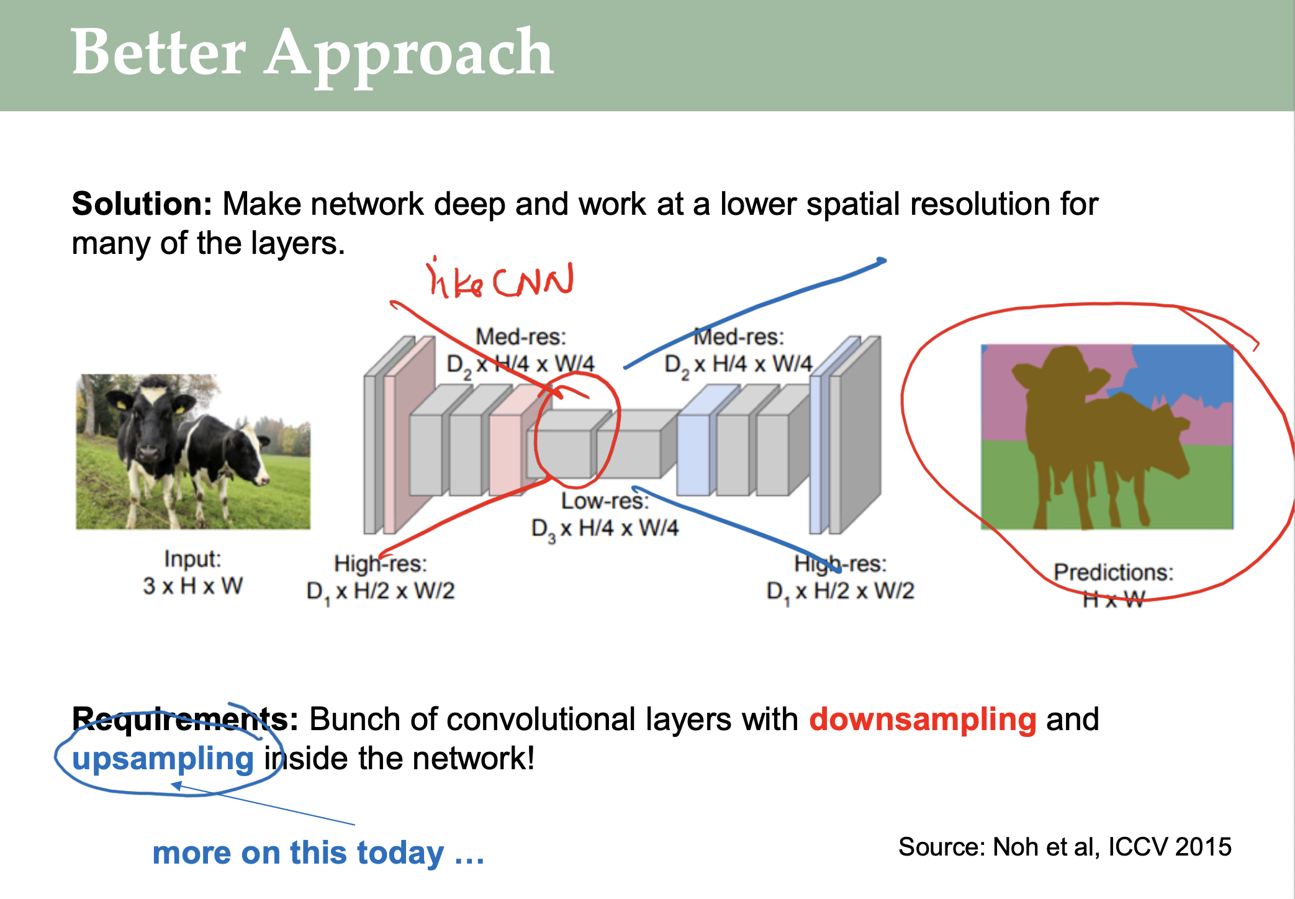
Receptive field 感受野 for each layer, one node in the net can see how much pixels of the original input image. Note that the each layer uses the last layer output as current layer input, so the later layer’s receptive field needs to be calculated based on stride and kernel size.
在autoencoder architecture中，receptive field = bottleneck = latent space
Autoencoder is self-supervised learning
For example, if stride=1 and kernel size=K, then
$$ReceptiveField_{layer1}=R_{1}=K$$
$$ReceptiveField_{layer2}=R_{2}=R_{1}+\left(K-1\right)$$
$$ReceptiveField_{layer2}=R_{3}=R_{2}+\left(K-1\right)=R_{1}+\left(K-1\right)*2$$
… The more general formula:
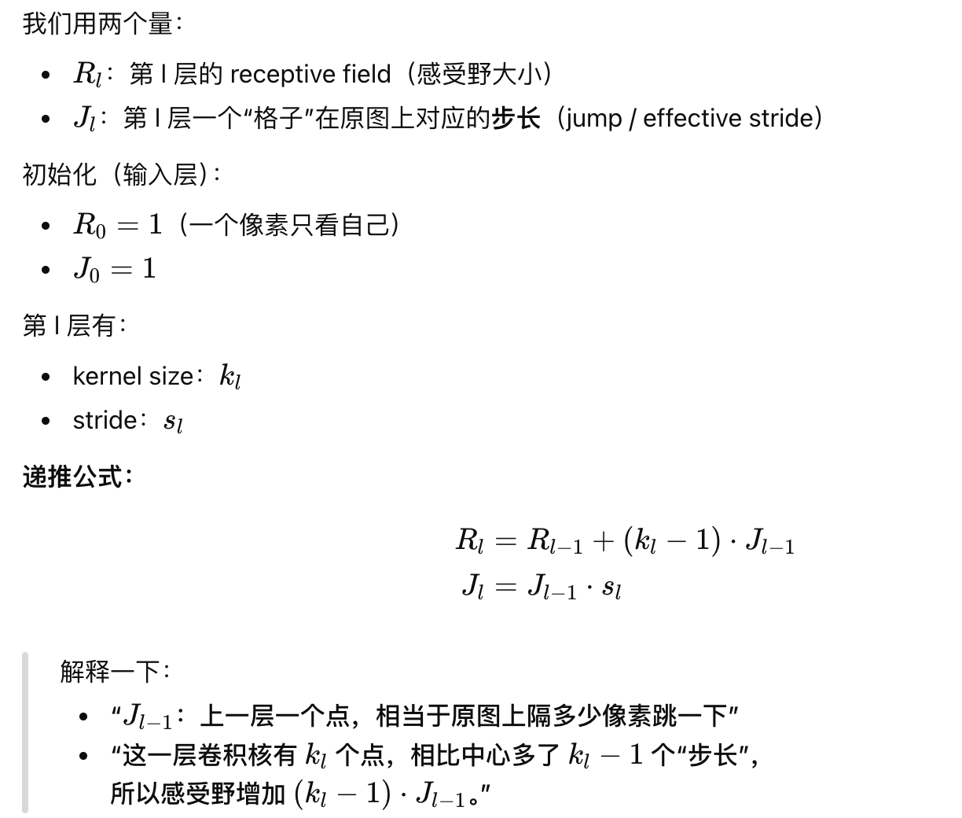
And example:
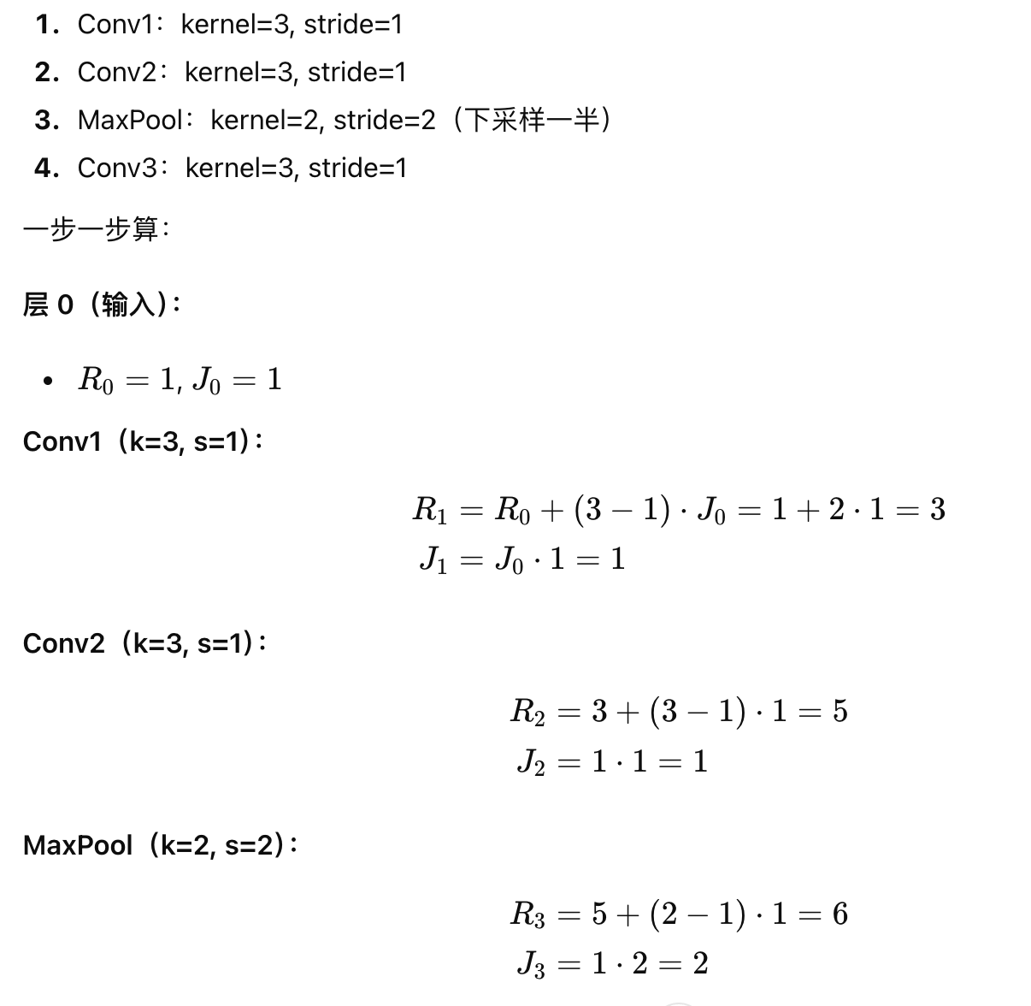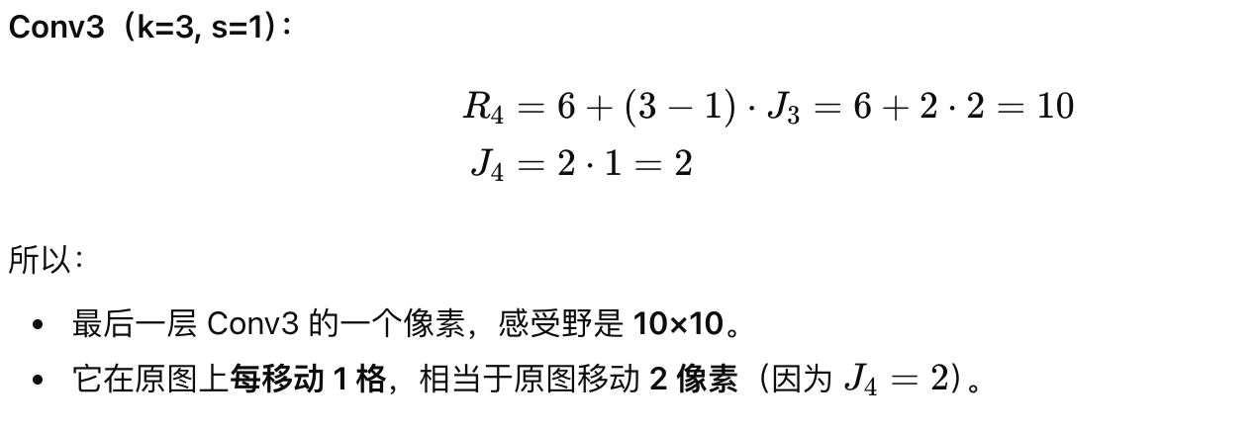
Receptive field is nothing with in/out channel numbers, but only relates to stride/kernek/#_layers. 这解释了在实际代码中，为什么bottleneck in_channel=out_channel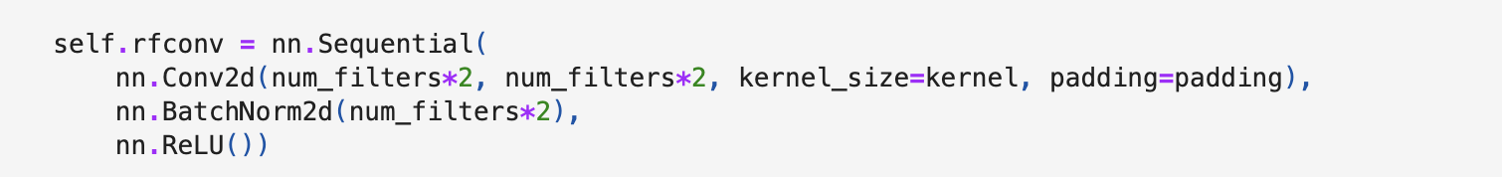
Downsampling 下采样 lower the image resolution and increase the channels (more channels to extract more features), model learns a small portion of the image each time – quicker learning and better receptive field
- Pooling
Upsampling 上采样 increase the image resolution from the compressed semantic features, then predict and classify each pixel with a semantic class.
- Transpose Convolution

Autoencoder
- Basic autoencoder is like encoder-decoder architecture, with
  - Input: image
  - Bottleneck/Latent Space – compress image features into a low-dim space
  - Output: image itself (reconstruction)
- Basic autoencoders are MLP – fully connected layers
- Basic autoencoder is for model learn the image patterns, not for image generation

VAE – Generative Probabilistic Autoencoder
Definition: the outputs are partly determined by chance even after the training
What? – (in on e sentence) Unlike basic autoencoder, for each image, the VAE trains an embedding space following the Gaussian distribution. The model samples from this distribution to generate output new image.
更多理解：传统AE对于每个图片生成一个固定embedding vector，这导致基于此embedding vector生成新图片的decoder每次生成的图片都是一样的（i.e. reconstruct image）。不同的是，对于每一个image，VAE会生成一个embedding space服从高斯分布，生成的新图片会从该分布中采样得到，这保证新图片的diversity。
Model Architecture:
- Similarity with AE: both have a CNN for representation learning
- Difference
  - VAE has 2 extra MLP as head after the CNN, to learn the $μ$ and $σ^{2}$ of Gaussian distribution (i.e. Normal distribution)
Loss Function:
- AE: MSE only (representation learning)
- VAE: MSE (representation learning)+ KL Divergence (distribution gap between real representation distribution and normal distribution)
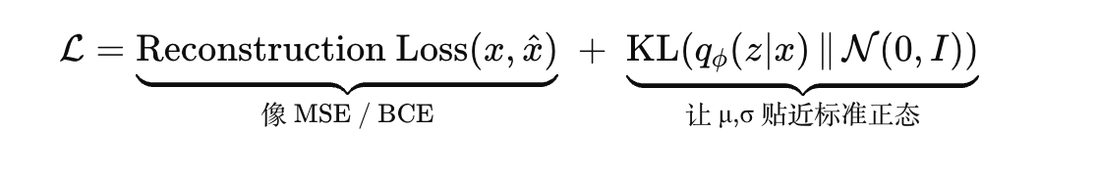
Where
$$MSE = \sqrt[2]{{\left|\left|x-\hat{x}\right|\right|}^{2}}$$
$KL(N(μ,σ^2 || N(0,I)) =$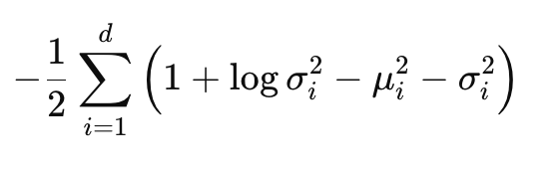
- Why KL matters?
普通 autoencoder：只要“记住训练图 → 重建像”，latent 乱没事。
VAE：要“记住 + 能从简单分布采样生成新图 + 插值平滑”，
所以必须用 KL 把 latent space 整理成一个 连续、密实、像 N(0,I) 的空间。
若不密实，分布会有很多洞，导致在embedding周围sample的新图像可能
会在洞里，那么生成的图像会far away

Autoencoder pretask
- Representation Learning
- Image Semantic Segmentation (Encoder-Decoder + Skip Connection/U-Net)
  - Downsampling, embedding space, upsampling;
  - U-Net link each encoder layer to a decoder layer, keeps both high-level semantic meaning (bottleneck) and low-level details (i.e. edges and textures) (in each layer features)
- Inpainting – mask a part of the image, fulfill / predict the missing part of the image
- Denoising – Diffusion Model is the application – goal is to learn representation still
- Image-to-image transformation (image colorization, winter to summer)

Autoencoder model coding
- Activation function: ReLU() for all CNN layers
- Loss: MSE
- Why final CNN is added even though the last upsampling layers already have an out channel = 3, means the colorized images? Answer: to remove the limitation by the ReLU() applied in the last upsampling layer, to improve the smoothness and flexibility of the final output

Model 1 - downsampling and upsampling only with Conv2d()

$$down sampling 1\underset{→}{Conv2d, MaxPooling}down smapling 2\underset{→}{Conv2d, MaxPooling}Bottleneck$$
$$\underset{→}{Conv2d, UpSampling}up sampling 1\underset{→}{Conv2d, Upsampling}upsamping 2\underset{→}{}finalcnnlayer\left(noReLU\right)$$

Model 2 – Downsampling (Conv2d()) + Upsampling(ConvTrans2d())
Model 3– Autoencoder with Skip Connection（全Conv2d）
- 考点：alignment between in_channel and out_channel; calculation of H & W, 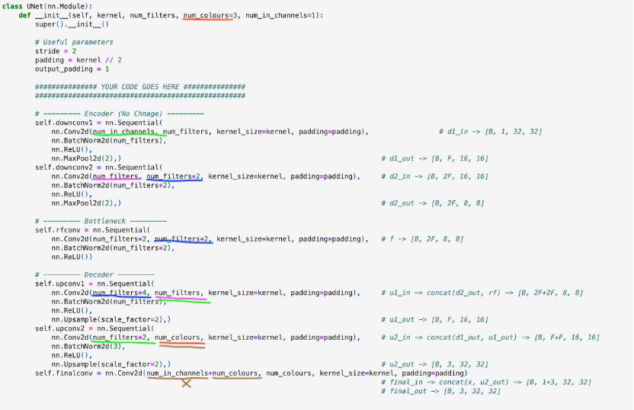

Week 7 GAN
Contrastive Learning
- What: Same input image, first apply image augmentation like crop, add noise, change color, or rotate; then (original image, augmented image) as positive pair; any other images pairs with one of the above image would be negative pair, because they are not the same image
- Model Architecture: put the positive pair into the CNN -> MLP, each image has an embedding vector – embedding vector similarity is small when two images are the rotation of the same image(同一张图的增强图片的向量相似度很高)
- Loss: InfoNCELoss – Attract positive pair, repel negative pair
- Why? - Learn representation, use self-learn from data augmentation
这两张内容中，可浅显的理解为embedding space之前的步骤合集叫encoder， 之后的为decoder
Diffusion Model
- What? – forward process [fixed formular] + reverse process [U-Net to learn]
- Let the model learns to predict noise and add noise following the Gaussian distribution, then use guidance text to tell the model to remove the noise step by step (as the step when add noise), finally get the original image
- Why? – learn representation of the image

Discriminative Model vs. Generative Model
- Definition:
  - Discriminative Model:
    - Output: $p\left(y | x\right)$
    - classify the image with a probability of which label it could be;
    - probability competes in labels and select the biggest one
  - Generative Model:
    - Learn x distribution
    - Output: sample from the learned x distribution $→$ output new images
    - Understands the training data, learn the patterns or representation learning, then generate new images
    - All possible images compete with each other’s probability density, 即每个class都有自己的probability density，给定一个prompt，哪个class的概率更高代表该class越可能被生成图片
    - 考点：Examples
- VAE
- Diffusion Model
- RNN
- Transformer

Why autoencoder generates blurry backgrounds?
The autoencoder is usually trained by MSE. The pixel values with image details, like edge or texture, may have larger or smaller pixel values. To minimize error, the MSE will average the pixel values where image details occur. This causes the blurry backgrounds

GAN – Generative Adversarial Networks

Vanilla GAN
Model Architecture & Properties
 | Discriminator | Generator
Definition | distinguish the real and fake images (generated by generator) | Generate fake images
Loss Fcn | BCE – fake or real classification on image | BCE – right or wrong of Discriminator’s classification (used to improve generator)
Prediction  1/0 | Real image – 1 (from training data);  Image by Generator – 0 (only images by Generator classification matters to Generator) | Discriminator classifies 1 for image by Generator – 1; Discriminator classifies 0 for image by Generator – 0;
!!Labels  0/1 | Real image – 0
Property |  | The more wrong the Discriminator is, the better the Generator is
Input | Only 1 input could be  - Real Image (from training data) or  - Fake images by Generator | Random Nosie (No original image at all, train to generate images that confuse the Discriminator)  Input = torch.random(batch_size, 100)
Output | Binary Classification | Fake Images (use BCE to improve)
Activation Function | LeakyReLU | LeakyReLU  Sigmoid at the end – let values in [0,1]
Risk | Can’t be too good – Generator won’t learn, because any weights changes in Generator training don’t impact the Discriminator classification (too good)
When to stop? – The accuracy for Discriminator is 50% (guess only)
[as it can’t distinguish/Generator is to good at generate fake image as real)
Need recap after this lesson completes

Problem with the GAN
Mode Collapse
- Definition: Model only learns 1 mode, which this mode will confuse the Discriminator successfully, so the Generator keeps generating the same images. It won’t generate other modes because the loss will be huge at the beginning of the learning, so the GAN model will go back to the learnt mode. This is why the mode generates 1.

- Resolution
  - Check mini-batch standard deviation in the Discriminator to distinguish the mode collapse
    - 如何判别是否有该问题: because
mini-batch + real data => high variance and
mini-batch + fake data => low variance
so we know a mini-batch with low variance could have mode collapse
  - Longer training time
  - Hyperparameter Tuning:
    - Batch norm
- Advantages:
  - Converge more smoothly
  - Prevent gradient vanishing or explosion
- Different use in Test/Training data
  - Test: use global batch mean and variance (updated for whenever a batch is trained)
  - Training: use current batch mean and variance

Conditional GAN
Definition
G：(z, grey) → fake color
D：(color, grey) → real / fake probability
Conditional GAN is available only if there is a pair of image (colorized image, greyscale image). Otherwise, use cycle GAN (next section)
Version 1
Inputs are different from Vanilla GAN – extra condition:
- Grayscale image (i.e. augmented original colorized image)
- Text
Model Architecture: CNN (generator) + MLP (Discriminator)
 | Discriminator | Generator
Input | 2 Inputs  - Real Image or Fake Image by Generator  - Grayscale Image – CONDITION  (simply concatenate by channels) | 2 Inputs  - Random Noise  - Grayscale Image – CONDITION  (simply concatenate by channels)
Output

Version 2
Model Architecture: Autoencoder (Generator) – MLP (Discriminator)
- Input for generator is same as vanilla GAN: only random noise
- Input for discriminator needs condition and real/fake image

Cycle GAN
Used when there is no paired images (like colorized to greyscale images)
2 generators and 1 discriminator

Deep Autoencoder/Stacked Autoencoder
Training method
Assume there are 3 hidden layers. First only train on input -> hidden layer 1 -> output, this will get an autoencoder to reconstruct a low resolution images. Then use this autoencoder train all input images as embedding vectors, use this embedding vectors as the new input for hidden layer 2 training, and etc.

VAE/Autoencoder is to learn representation, GAN is the following model to improve the generated image quality

Adversarial Attack
Definition: Learn a small epsilon as the noise parameter to add to the image
Goal: Let the model predict wrongly
2 Ways of Adversarial Attack:
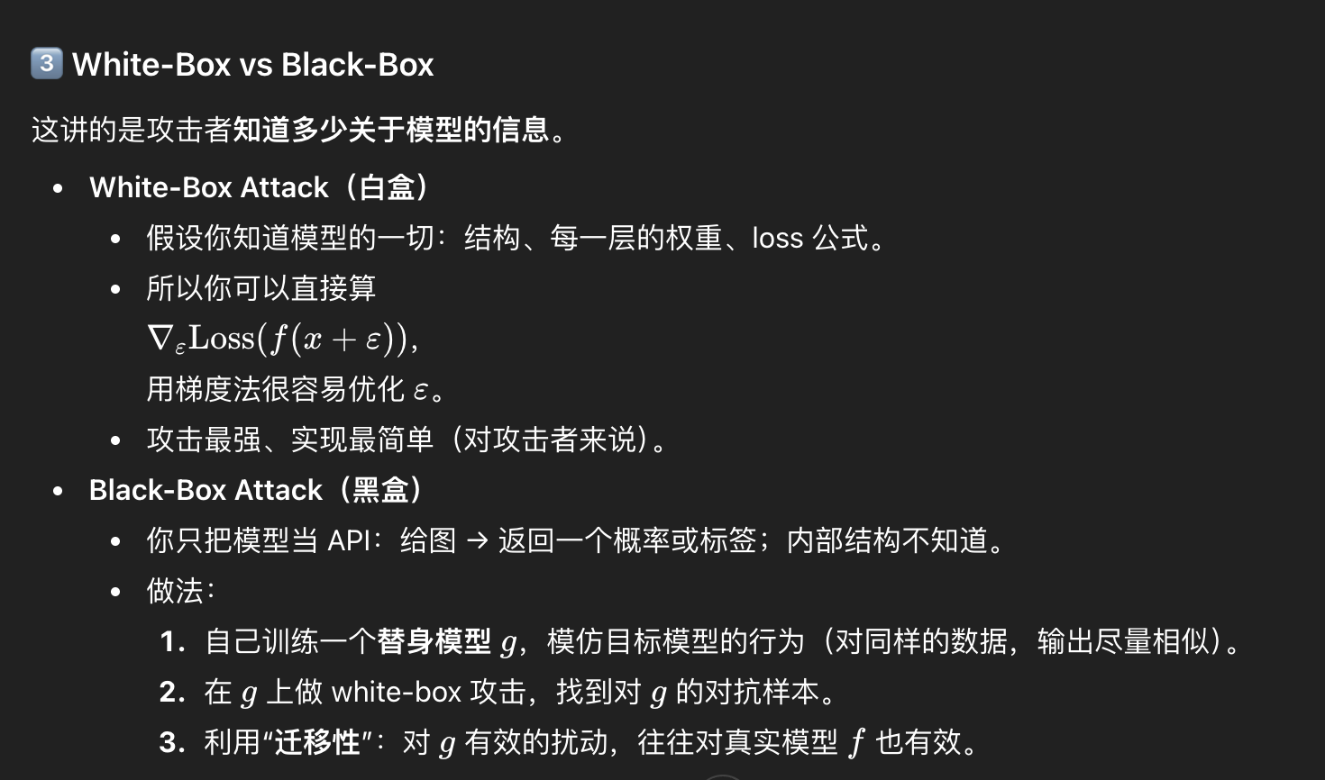
Failed Defence